

SOFE 3490U Software Project Management

Lab 3

**Group Members:**

|  |  |
| --- | --- |
| *Student Name* | *Student Number* |
| Kavya Raman | 100615001 |
| Shivani Wazalwar | 100618621 |
| Abdul Zainul-Abedin | 100617275 |

**Calculate Estimated Effort**

We used the COCOMO model:

E = a(KLOC)^b

a = 3.0 b = 1.12

KLOC- Since this is a mobile application, and based on our anecdotal experience with mobile apps, we think that the total lines of code will be 4000

E = 3*(4^1.12) = 14.17

This project will require **14 person-months of effort**. Since we have 3 developers, the total development time will be **4.7 months**

**Activity Diagram**

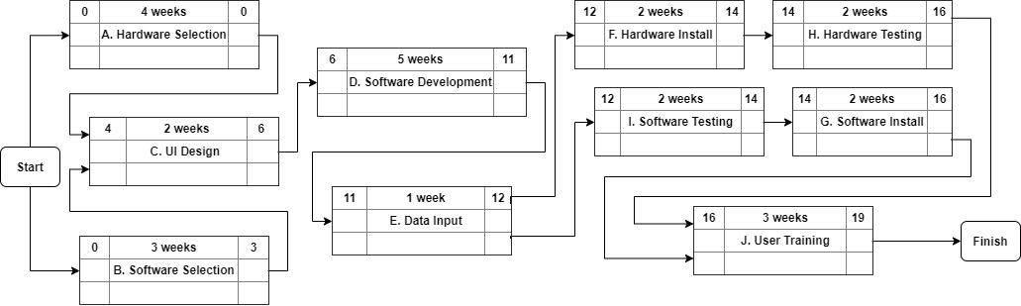

**Risks and Countermeasures**

* Software compatibility
  + Tablets may become outdated and thus the software would have to remain compatible
  + FIX: Ensure that the software has compatibility with the chosen tablets in the hardware selection task, have patches to maintain the code and keep up to date with new hardware changes as they come
* Ease of use
  + Takes time to get used to and may cause businesses losses during the transition
  + FIX: give ample training to the kitchen and wait staff as well as easy to understand instructions for first-time customers
* Internet connectivity issues
  + If the internet stops working or if there are any connection issues, then the application may be rendered useless
  + FIX: We can enable features such that the menu is cached on the devices, so the guests can still view the menu even if the devices do not connect to the internet. Customers will still have to speak to an employee to place their order until the internet connectivity is resolved though.